Q. Why string is immutable in java
Here are some of the reasons why strings are immutable in Java:
- Security:
String immutability prevents hackers from changing the referenced value, which could cause security issues. For example, if a hacker could change the value of a string that represents a user's password, they could gain access to the user's account.
- Performance:
String immutability can improve performance by allowing the Java Virtual Machine (JVM) to cache string objects. When a string is immutable, the JVM knows that the value of the string will never change, so it can safely cache the string object and reuse it whenever it is needed. This can save time and memory.
- Thread safety:
String immutability makes string objects thread-safe. This means that multiple threads can access the same string object without causing any problems. This is because the value of the string object will never change, so there is no risk of one thread accidentally modifying the string object while another thread is using it.

Q. Can we override the static methods?
No, we cannot override static methods in Java. Static methods are bound at compile-time, which means that the compiler determines which method to call based on the static type of the reference. Overriding, on the other hand, is a runtime polymorphism feature that allows a subclass to provide a different implementation of a method inherited from its superclass. Since static methods are not bound at runtime, they cannot be overridden.

Q.What if the static modifier is removed from the signature of the main method?
Program compiles. However, at runtime, It throws an error "NoSuchMethodError."

Q. Can we make constructors static?
As we know that the static context (method, block, or variable) belongs to the class, not the object. Since Constructors are invoked only when the object is created, there is no sense to make the constructors static. However, if you try to do so, the compiler will show the compiler error.

Q. Can we make the abstract methods static in Java?
In Java, if we make the abstract methods static, It will become the part of the class, and we can directly call it which is unnecessary. Calling an undefined method is completely useless therefore it is not allowed.

Q. Can we declare the static variables and methods in an abstract class?
Yes, we can declare static variables and methods in an abstract class. As we know that there is no requirement to make the object to access the static context, therefore, we can access the static context declared inside the abstract class by using the name of the abstract class

Q. Can this keyword be used to refer static members?
Yes, It is possible to use this keyword to refer static members because this is just a reference variable which refers to the current class object. However, as we know that, it is unnecessary to access static variables through objects, therefore, it is not the best practice to use this to refer static members.

Q. Can you use this() and super() both in a constructor?
No, because this() and super() must be the first statement in the class constructor.

Q. What is object cloning?
The object cloning is used to create the exact copy of an object. The clone() method of the Object class is used to clone an object. The java.lang.Cloneable interface must be implemented by the class whose object clone we want to create. If we don't implement Cloneable interface, clone() method generates CloneNotSupportedException.

Q. Can you overload a method by changing its return type?
No, you cannot overload a method by changing its return type. In most programming languages, including Java and C#, the compiler uses the method signature to determine which method to call. The signature includes the method name and the data types of its parameters, but not the return type.
Therefore, if two methods have the same name and the same parameter types, the compiler cannot distinguish between them and will throw an error.
Here's why changing the return type doesn't work for overloading:
- Ambiguity:
If multiple methods have the same name and parameters but different return types, the compiler wouldn't know which method to call based on the arguments provided. This ambiguity would lead to errors.
- Unpredictable behavior:
Changing the return type would essentially create two different methods with the same name, making the code less readable and potentially causing unexpected behavior.
Alternatives to overloading by return type:
- Overload by parameter types:
This is the standard way to overload methods. You can create multiple methods with the same name but different parameter types, allowing you to handle different types of inputs.
- Use different method names:
If you need methods with the same functionality but different return types, consider using different names to differentiate them.

Q. Why is method overloading not possible by changing the return type in java?
In Java, method overloading is not possible by changing the return type of the program due to avoid the ambiguity.

Q. Can we overload the methods by making them static?
Yes, we can overload methods by making them static. This is called static method overloading. Static method overloading is a feature of Java that allows us to have two or more methods with the same name in the same class, but with different parameters.

Q. Can constructor be polymorphic?
No, constructors cannot be polymorphic. We can have many constructors in class with different input, but they don’t behave differently based on the object type like methods do.

Q. Can a constructor be synchronized in Java? Why or why not?
No, a constructor cannot be synchronized in Java. Synchronizing a constructor does not make sense because it is used to create an instance of a class. The very purpose of synchronization is to ensure that only one thread can execute a method or block at a time on a given instance of a class. Since a constructor is used to create an instance, there is no existing instance to lock on for synchronization.

Q. Can we override the overloaded method?
Yes.

Q. Can we override the private methods?
No, we cannot override the private methods because the scope of private methods is limited to the class and we cannot access them outside of the class.

Q. Is it possible for a subclass to inherit private members of a superclass? How can it access them?
- No, a subclass cannot inherit the private members (fields and methods) of its superclass directly. Private members are only accessible within the class they are declared in.
- But Using Getter and Setter we can access private members of superclass.

Q. Can we change the scope of the overridden method in the subclass?
Yes, we can change the scope of the overridden method in the subclass. However, we must notice that we cannot decrease the accessibility of the method. The following point must be taken care of while changing the accessibility of the method.
- The private can be changed to protected, public, or default.
- The protected can be changed to public or default.
- The default can be changed to public.
- The public will always remain public.

Q. Can you have virtual functions in Java?
Yes, all functions in Java are virtual by default.

Q. Can we initialize the final blank variable?
Yes, if it is not static, we can initialize it in the constructor. If it is static blank final variable, it can be initialized only in the static block.

Q. Can you declare the main method as final?
Yes, We can declare the main method as public static final void main(String[] args){}.

Q. Can we declare a constructor as final?
The constructor can never be declared as final because it is never inherited. Constructors are not ordinary methods; therefore, there is no sense to declare constructors as final. However, if you try to do so, The compiler will throw an error.

Q. Can a class extends on its own?
No, a class in java cannot extends itself. If it tries, it will cause an error.

Q. What is the difference between the final method and abstract method?
The main difference between the final method and abstract method is that the abstract method cannot be final as we need to override them in the subclass to give its definition.

Q. Can you achieve Runtime Polymorphism by data members?
No, because method overriding is used to achieve runtime polymorphism and data members cannot be overridden. We can override the member functions but not the data members.

Q. Can you achieve Runtime Polymorphism by data members?
No, because method overriding is used to achieve runtime polymorphism and data members cannot be overridden. We can override the member functions but not the data members. Consider the example given below.

Q. Can there be an abstract method without an abstract class?
No, if there is an abstract method in a class, that class must be abstract.

Q. Can you use abstract and final both with a method?
No, because we need to override the abstract method to provide its implementation, whereas we can't override the final method.
Q. Can a class be declared as both abstract and final? Why or why not?
No, a class cannot be declared as both abstract and final.
- Abstract class: A class declared as abstract cannot be instantiated and is meant to be subclassed. It may contain abstract methods that must be implemented by its subclasses.
- Final class: A class declared as final cannot be subclassed, meaning no other class can extend it.

Q. Can you instantiate an abstract class in Java? If not, how can you use an abstract class?
- No, you cannot instantiate an abstract class in Java. However, you can use an abstract class by:
- Creating a subclass that extends the abstract class and provides implementations for its abstract methods.
- Instantiating the subclass instead of the abstract class.
Q. Can you create an instance of an abstract class? If not, how can abstract classes be useful?

Q. Can you declare an interface method static?
No, because methods of an interface are abstract by default, and we can not use static and abstract together.

Q. Can we declare an interface as final?
No, we cannot declare an interface as final because the interface must be implemented by some class to provide its definition. Therefore, there is no sense to make an interface final. However, if you try to do so, the compiler will show an error.

Q. Can we define private and protected modifiers for the members in interfaces?
No, they are implicitly public.
Q. Can you provide example of when to use an interface versus when to extend a class?
Use an interface when we want to list the methods a class should have, without detailing how they work. Use class extension when we want a new class to inherit features and behaviours from an existing class and possibly modify them.

Q. What is the difference between composition and inheritance? When would you prefer one over the other?
- Inheritance: Represents an "is-a" relationship. It is used when you want to create a new class that is a type of an existing class. It provides code reuse and polymorphism.
- Composition: Represents a "has-a" relationship. It is used when you want to create a class that contains instances of other classes. It provides better flexibility and encapsulation.

Q. Can a class inherit from multiple classes in Java? If not, how can you achieve similar functionality?
No, a class cannot inherit from multiple classes in Java due to the diamond problem and to keep the language simple and clean. However, similar functionality can be achieved using interfaces and composition.
- Interfaces: A class can implement multiple interfaces, thus allowing it to inherit behavior from multiple sources.
- Composition: Instead of inheriting from multiple classes, a class can hold references to other classes and delegate calls to them.

Q. How to make a read-only class in Java?
A class can be made read-only by making all of the fields private. The read-only class will have only getter methods which return the private property of the class to the main method. We cannot modify this property because there is no setter method available in the class.

Q. Why java uses the concept of the string literal?
To make Java more memory efficient (because no new objects are created if it exists already in the string constant pool).
Q. How to make a write-only class in Java?
A class can be made write-only by making all of the fields private. The write-only class will have only setter methods which set the value passed from the main method to the private fields. We cannot read the properties of the class because there is no getter method in this class.

Q. What is the purpose of toString() method in Java?
The toString() method returns the string representation of an object. If you print any object, java compiler internally invokes the toString() method on the object. So overriding the toString() method, returns the desired output, it can be the state of an object, etc. depending upon your implementation. By overriding the toString() method of the Object class, we can return the values of the object, so we don't need to write much code.

Q. Why CharArray() is preferred over String to store the password?
String stays in the string pool until the garbage is collected. If we store the password into a string, it stays in the memory for a longer period, and anyone having the memory-dump can extract the password as clear text. On the other hand, Using CharArray allows us to set it to blank whenever we are done with the password. It avoids the security threat with the string by enabling us to control the memory.

Q. How to synchronize ArrayList?
We can synchronize ArrayList in two ways.
- Using Collections.synchronizedList() method

Q. What is the memory leak?
A memory leak in Java is a type of programming error that occurs when an object is no longer being used by the application, but it is still stored in memory. This can happen for a variety of reasons, such as:
- Static variables:
Static variables are stored in memory for the entire duration of the program, even if they are no longer being used.
- Singletons:
Singletons are objects that are only created once and then shared throughout the program. If a singleton is not properly cleaned up, it can cause a memory leak.
- Listeners:
Listeners are objects that are notified when certain events occur. If a listener is not properly unregistered, it can cause a memory leak.
- Callbacks:
Callbacks are functions that are passed to other functions as arguments. If a callback is not properly unregistered, it can cause a memory leak.
- Caching:
Caching is a technique that stores data in memory so that it can be accessed more quickly. If a cache is not properly managed, it can cause a memory leak.
- Inner classes:
Inner classes are classes that are defined within another class. If an inner class is not properly cleaned up, it can cause a memory leak.
- Closing resources:
Resources, such as database connections and file handles, should be closed when they are no longer needed. If a resource is not closed, it can cause a memory leak.

Q. What is the purpose of the instanceof keyword in Java? Can it be used with interfaces?
The instanceof keyword is used to test whether an object is an instance of a specific class or implements a specific interface. Yes, instanceof can be used with interfaces to check if an object implements a particular interface.

Q. What are inner classes in Java? Explain the different types of inner classes and their use cases.
- Inner classes are classes defined within another class. The different types of inner classes are:
  - Member Inner Class: Defined within the body of an outer class and has access to its members. Used when a class is closely associated with another class.
  - Static Nested Class: Defined with the static keyword. It can access only the static members of the outer class. Used when the nested class is related to the outer class but does not require access to its instance members.
  - Local Inner Class: Defined within a block, such as a method or an initializer block. Used for quick, one-off implementations that are closely tied to the method.
  - Anonymous Inner Class: Defined and instantiated in one place using the new keyword. Used for implementing interfaces or extending classes in a concise way.

Q. What is a singleton class? How do you ensure that a class follows the singleton pattern in Java?
A singleton class is a class that allows only one instance of itself to be created. To ensure a class follows the singleton pattern in Java:
- Make the constructor private to prevent instantiation from other classes.
- Create a private static instance of the class.
- Provide a public static method that returns the instance of the class.

Q. What is the difference between shallow copy and deep copy in Java? How would you implement each?
- Shallow Copy: A shallow copy of an object copies the object's field values. If the field value is a reference to an object, it copies the reference, meaning both the original and the copied objects share the same reference.
- Deep Copy: A deep copy copies all fields and makes copies of dynamically allocated memory pointed to by the fields. In essence, it creates a new instance of the object along with copies of the objects it references.

Q. What is Method reference in Java 8?
- Method reference used to create simple lambda expressions by referencing existing methods.
- They are often used to create simple lambda expressions by referencing existing methods.
- Each time when you are using lambda expression to just referring a method, you can replace your lambda expression with method reference.
Types of Method References
There are following types of method references in java:
- Reference to a static method.
- Reference to an instance method.
- Reference to a constructor.

Q. How many entries you can store in HashMap? What is the maximum limit?
- No limit for hashmap to store the elements
- But if we execute the size() method, it return value in “int” datatype and “int” has size limit.
- To overcome this problem mappingCount() method is introduce in Java 8 and it return long value

Q. What is Fail-Fast in Java?
Fail-fast is a mechanism in Java that throws a ConcurrentModificationException if a collection is modified while it is being iterated over.
Q. What is Hash Collision in java?
A hash collision in Java occurs when two or more different keys are mapped to the same hash value. This can happen because the hash function is not perfect, and it is possible for two different keys to produce the same hash code.
When a hash collision occurs, the Java HashMap class uses a technique called separate chaining to resolve the collision. Separate chaining uses a linked list to store the values that are mapped to the same hash value. When a new key is added to the HashMap, the key's hash code is calculated, and the key-value pair is added to the linked list at the corresponding index in the HashMap's array.

Q. What is ConcurrentHashMap in Java ?
The ConcurrentHashMap class is introduced in JDK 1.5 belongs to java.util.concurrent package, which implements ConcurrentMap as well as to Serializable interface also. ConcurrentHashMap is an enhancement of HashMap as we know that while dealing with Threads in our application HashMap is not a good choice because performance-wise HashMap is not up to the mark.
ConcurrentHashMap is a thread-safe implementation of the Map interface in Java, which means multiple threads can access it simultaneously without any synchronization issues.

Q. When does ConcurrentModificationException occurs?
The ConcurrentModificationException is thrown when a collection is modified while it is being iterated over. This can happen when you try to add or remove elements from a collection, like a list, during iteration. The exception is triggered by the fail-fast behavior of Java's collection classes.

Q. What is race-condition?
A Race condition is a problem which occurs in the multithreaded programming when various threads execute simultaneously accessing a shared resource at the same time. The proper use of synchronization can avoid the Race condition.

Q. Which is better way to create threads?
In Java, there are two ways to create a thread: extending the Thread class or implementing the Runnable interface:
- Extending the Thread class
This method involves creating a new class that extends the Thread class and then creating an instance of that class. You can override the run() method to expand the functionality of Thread. However, this method doesn't allow you to extend any other class, and each thread creates a unique object.
- Implementing the Runnable interface
This method involves creating a class that implements the Runnable interface. It's generally considered the easier way to create a thread, and it allows your class to extend other classes in the future. It also shares the same object among multiple threads.

Q. What do you understand by inter-thread communication?
- The process of communication between synchronized threads is termed as inter-thread communication.
- Inter-thread communication is used to avoid thread polling in Java.
- The thread is paused running in its critical section, and another thread is allowed to enter (or lock) in the same critical section to be executed.
- It can be obtained by wait(), notify(), and notifyAll() methods.

Q. What is a marker interface?
A Marker interface can be defined as the interface which has no data member and member functions. For example, Serializable, Cloneable are marker interfaces. The marker interface can be declared as follows.
There are many built-in marker interfaces some of them are:
- Cloneable Interface
- Serializable Interface
- Remote Interface

Q. What is the package?
A package is a group of similar type of classes, interfaces, and sub-packages. It provides access protection and removes naming collision. The packages in Java can be categorized into two forms, inbuilt package, and user-defined package. There are many built-in packages such as Java, lang, awt, javax, swing, net, io, util, sql, etc.

Q. Do I need to import java.lang package any time? Why?
No. It is by default loaded internally by the JVM.

Q. How many types of exception can occur in a Java program?
There are mainly two types of exceptions: checked and unchecked. Here, an error is considered as the unchecked exception. According to Oracle, there are three types of exceptions:
- Checked Exception: Checked exceptions are the one which are checked at compile-time. For example, SQLException, ClassNotFoundException, etc.
- Unchecked Exception: Unchecked exceptions are the one which are handled at runtime because they can not be checked at compile-time. For example, ArithmaticException, NullPointerException, ArrayIndexOutOfBoundsException, etc.
- Error: Error cause the program to exit since they are not recoverable. For Example, OutOfMemoryError, AssertionError, etc.

Q. What kind of thread is the Garbage collector thread?
Daemon thread.

Q. Is it necessary that each try block must be followed by a catch block?
The answer is “No, it is not mandatory that each try block must be followed by a catch block in Java.” After try block, we can use either “catch” block or “finally” block. Generally, thrown exceptions should be declared in the thrown clause of the method.
Q. Explain the hierarchy of Java Exception classes?
The java.lang.Throwable class is the root class of Java Exception hierarchy which is inherited by two subclasses: Exception and Error. A hierarchy of Java Exception classes are given below:

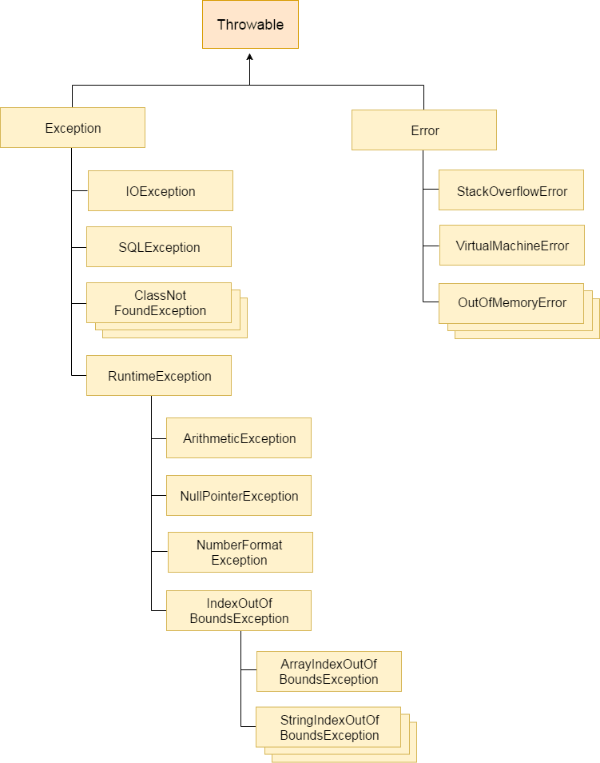

Q. Can finally block be used without a catch?
Yes, According to the definition of finally block, it must be followed by a try or catch block, therefore, we can use try block instead of catch.

Q. What is the difference between throw and throws?
throw keyword | throws keyword
1) The throw keyword is used to throw an exception explicitly. | The throws keyword is used to declare an exception.
2) The checked exceptions cannot be propagated with throw only. | The checked exception can be propagated with throws
3) The throw keyword is followed by an instance. | The throws keyword is followed by class.
4) The throw keyword is used within the method. | The throws keyword is used with the method signature.
5) You cannot throw multiple exceptions. | You can declare multiple exceptions, e.g., public void method()throws IOException, SQLException.

Q. What is the meaning of immutable regarding String?
The simple meaning of immutable is unmodifiable or unchangeable. In Java, String is immutable, i.e., once string object has been created, its value can't be changed.

Q. How many ways can we create the string object?
- 1) String Literal { String s="welcome"; }
2) By new keyword { String s=new String("Welcome"); }

Q. Why java uses the concept of the string literal?
To make Java more memory efficient (because no new objects are created if it exists already in the string constant pool).

Q. How can we create an immutable class in Java?
We can create an immutable class by defining a final class having all of its members as final.

Q. What is String Pool?
String pool is the space reserved in the heap memory that can be used to store the strings. The main advantage of using the String pool is whenever we create a string literal; the JVM checks the "string constant pool" first. If the string already exists in the pool, a reference to the pooled instance is returned. If the string doesn't exist in the pool, a new string instance is created and placed in the pool. Therefore, it saves the memory by avoiding the duplicacy.
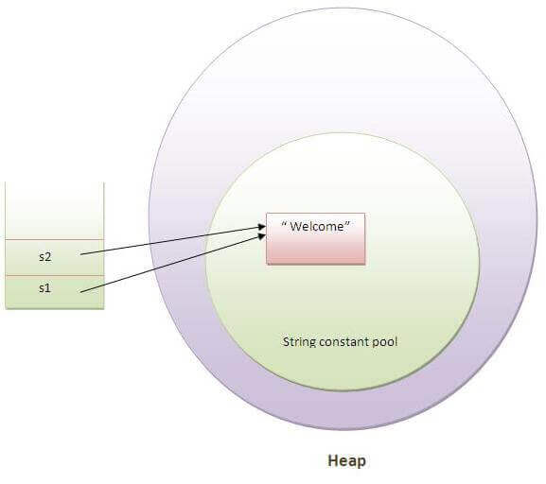

Q. What is gc()?
The gc() method is used to invoke the garbage collector for cleanup processing. This method is found in System and Runtime classes. This function explicitly makes the Java Virtual Machine free up the space occupied by the unused objects so that it can be utilized or reused.

Q. What is the difference between final, finally and finalize?
final | finally | finalize
Final is used to apply restrictions on class, method, and variable. The final class can't be inherited, final method can't be overridden, and final variable value can't be changed. | Finally is used to place important code, it will be executed whether an exception is handled or not. | Finalize is used to perform clean up processing just before an object is garbage collected.
Final is a keyword. | Finally is a block. | Finalize is a method.

Q. What is serialization and deserialization?
- Serialization in Java is a mechanism of writing the state of an object into a byte-stream.
- The reverse operation of serialization is called deserialization where byte-stream is converted into an object.
- The serialization and deserialization process is platform-independent, it means you can serialize an object on one platform and deserialize it on a different platform.
- For serializing the object, we call the writeObject() method of ObjectOutputStream class, and for deserialization we call the readObject() method of ObjectInputStream class.

Q. What is the Collection framework in Java?
- Collection Framework is a combination of classes and interface, which is used to store and manipulate the data in the form of objects.
- It provides various classes such as ArrayList, Vector, Stack, and HashSet, etc. and interfaces such as List, Queue, Set, etc. for this purpose.

Q. What is the difference between ArrayList and Vector?
No. | ArrayList | Vector
1) | ArrayList is not synchronized. | Vector is synchronized.
2) | ArrayList is not a legacy class. | Vector is a legacy class.
3) | ArrayList increases its size by 50% of the array size. | Vector increases its size by doubling the array size.
4) | ArrayList is not thread-safe as it is not synchronized. | Vector list is thread-safe as it’s every method is synchronized.

Q. What is the difference between Iterator and Enumeration?
No. | Iterator | Enumeration
1) | The Iterator can traverse legacy and non-legacy elements. | Enumeration can traverse only legacy elements.
2) | The Iterator is fail-fast. | Enumeration is not fail-fast.
3) | The Iterator is slower than Enumeration. | Enumeration is faster than Iterator.
4) | The Iterator can perform remove operation while traversing the collection. | The Enumeration can perform only traverse operation on the collection.

Q. What are the new java features in jdk1.8?

- Lambda expressions,
- Method references,
- Functional interfaces,
- Stream API,
- Default methods,
- Static methods in interface,
- Optional class,
- ForEach() method

Q. What is the difference between HashMap and Hashtable?
No. | HashMap | Hashtable
1) | HashMap is not synchronized. | Hashtable is synchronized.
2) | HashMap can contain one null key and multiple null values. | Hashtable cannot contain any null key or null value.
3) | HashMap is not thread-safe, so it is useful for non-threaded applications. | Hashtable is thread-safe, and it can be shared between various threads.
4) | HashMap inherits the AbstractMap class | Hashtable inherits the Dictionary class.

Q. Difference between hashmap and concurrenthashmap
Parameters | HashMap | ConcurrentHashMap
Synchronization | Non-synchronized | synchronized
Thread-safety | Not thread-safe | Thread-safe
Iterator | It is fail-fast and throws an exception during iteration | It is fail-safe and performs iteration by multiple threads
Null Values | It allows for storing null keys and values. | It does not allow to store null key/values.
Performance | faster | Slower than Hashmap

Q. What is the use of optional class?
The Optional class in Java 8 is a container object which is used to contain a value that might or might not be present. It was introduced as a way to help reduce the number of NullPointerExceptions that occur in Java code.

Q. What is Default methods?
- A default method is a method in an interface that has a method body. It is a new feature in Java 8. Before Java 8, interfaces could only declare abstract methods.
- Default methods are useful for providing backward compatibility. For example, if you have an interface that is used by many classes, you can add a new default method to the interface without breaking the existing classes.
- Default methods are also useful for providing utility methods. For example, you can add a default method to an interface to sort a list. This means that any class that implements the interface can use the sort method without having to implement it themselves.

Q. What is lambda expression?
- Lambda Expressions were added in Java 8.
- A lambda expression is a short block of code which takes in parameters and returns a value. Lambda expressions are similar to methods, but they do not need a name and they can be implemented right in the body of a method.
- Lambda expression provides implementation of functional interface.

Q. What is stream api?
- It was introduced in Java 8 and is part of the java.util.stream package. Stream API is used to process collections of objects.
- A stream in Java is a sequence of objects that supports various methods such as filtering, mapping, sorting, and aggregating. which can be pipelined to produce the desired result.

Q. What is method hiding?
Method hiding can be defined as, "if a subclass defines a static method with the same signature as a static method in the super class, in such a case, the method in the subclass hides the one in the superclass." The mechanism is known as method hiding.

Q. What is the difference between consumer and Biconsumer interface?
The Consumer and BiConsumer interfaces are both functional interfaces provided by the Java API for handling different types of functions that consume input but differ in the number of input arguments they accept.
- Consumer Interface:
Definition: The Consumer interface is a functional interface that represents an operation that accepts a single input argument and returns no result.
Method: It defines a single method void accept(T t) that takes one argument and performs an operation on it.
Usage: Consumer is commonly used for operations that need to be performed on each element of a collection or stream.
- BiConsumer Interface:
Definition: The BiConsumer interface is a functional interface that represents an operation that accepts two input arguments and returns no result.
Method: It defines a single method void accept(T t, U u) that takes two arguments and performs an operation on them.
Usage: BiConsumer is commonly used for operations that need to be performed on pairs of elements or for processing entries of a map.
Difference:
The key difference between Consumer and BiConsumer lies in the number of input arguments they accept:
1. Consumer accepts a single input argument.
2. BiConsumer accepts two input arguments.

Q. What is static block?
A static block in Java is a block of code that is executed only once, when the class is first loaded into memory. It is typically used for initializing static variables, and it can also be used to perform any one-time computations or setup operations.

Q. What is the difference between overloading and overriding? good
First and most important difference between method overloading and overriding is that in the case of method overloading in Java, the signature of the method changes while in the case of method overriding it remains the same.
Second major difference between method overloading vs overriding in Java is that You can overload the method in one class but overriding can only be done on the subclass.
You cannot override static, final, and private methods in Java but you can overload static, final, or private methods in Java.
Overloaded method in Java is bonded by static binding and overridden methods are subject to the dynamic binding.

Q. What is the difference between implicit and explicit? good
In Java, implicit means something is done by the compiler, while explicit means something is done by the programmer.
Here are some examples of implicit and explicit in Java:
- Implicit:
  - The compiler will implicitly create a default constructor for a class if the programmer does not explicitly create one.
  - The compiler will implicitly cast a smaller data type to a larger data type when there is no loss of data.
- Explicit:
  - The programmer can explicitly create a constructor for a class.
  - The programmer can explicitly cast a larger data type to a smaller data type.

Q. What is scp?
SCP stands for String Constant Pool. It is a special area in the Java heap memory where string literals are stored. String literals are strings that are directly written in the code, such as "Hello, world!".
When the Java Virtual Machine (JVM) loads a class, it creates a string constant pool for that class. The string constant pool stores all of the string literals that are used in the class.
When you create a new string object using the new keyword, the JVM checks to see if the string literal already exists in the string constant pool. If it does, the JVM returns a reference to the existing string object. If the string literal does not exist in the string constant pool, the JVM creates a new string object and stores it in the string constant pool.
The string constant pool is used to improve the performance and memory efficiency of Java programs. By storing string literals in the string constant pool, the JVM can avoid creating multiple copies of the same string. This can save a significant amount of memory, especially in programs that use a lot of strings.

Q. What is the difference between heap and stack?
Parameter | STACK AREA | HEAP AREA
Basic | Memory is allocated in a contiguous block. | Memory is allocated in any random order.
Allocation and De-allocation | Automatic by compiler instructions. | Manual by the programmer.
Cost | Less | More
Implementation | Easy | Hard
Access time | Faster | Slower
Main Issue | Shortage of memory | Memory fragmentation
Safety | Thread safe, data stored can only be accessed by the owner | Not Thread safe, data stored visible to all threads
Flexibility | Fixed-size | Resizing is possible
Data type structure | Linear | Hierarchical
Size | Small than heap memory. | Larger than stack memory.

Q. If a method throws NullPointerException in the superclass, can we override it with a method that throws RuntimeException?
The answer is you can very well throw a superclass of RuntimeException in overridden method, but you cannot do the same if it's checked Exception.

- Handling Exception while overloading and overriding method in Java
While overriding a method it can only throw checked exception declared by overridden method or any subclass of it, which means if the overridden method throws IOExcpetion then the overriding method can throw sub classes of IOExcpetion like FileNotFoundException but not wider exception like Exception or Throwable.
This restriction is only for checked Exception for RuntimeException you can throw any RuntimeException. The overloaded method in Java doesn't have such restrictions and you are free to modify the throws clause as per your need.

Q. What will happen if you put the return statement or System.exit () on the try or catch block? Will finally block execute?
The finally block will execute even if you put a return statement in the try block or catch block but finally block won't run if you call System.exit() from the try or catch block.

Q. Can you override a private or static method in Java?
you cannot override a private or static method in Java, if you create a similar method with the same return type and same method arguments in child class then it will hide the superclass method, this is known as method hiding.
Similarly, you cannot override a private method in subclass because it's not accessible there, what you do is create another private method with the same name in the child class.

Q. What will happen if we put a key object in a HashMap which is already there?
- if you put the same key again then it will replace the old mapping because HashMap doesn't allow duplicate keys. The Same key will result in the same hashcode and will end up at the same position in the bucket.
- Each bucket contains a linked list of Map.Entry object, which contains both Key and Value. Now Java will take the Key object from each entry and compare it with this new key using the equals() method, if that returns true then the value object in that entry will be replaced by the new value.

Q. What is the difference between StringBuffer and StringBuilder in Java?
- The only difference between both of them is that StringBuffer methods like length(), capacity(), or append() are synchronized while corresponding methods in StringBuilder are not synchronized.
- Because of this fundamental difference, concatenation of String using StringBuilder is faster than StringBuffer. Actually, it's considered a bad practice to use StringBuffer anymore, because, in almost 99% of scenarios, you perform string concatenation on the same thread. See StringBuilder vs StringBuffer for more differences.

Q. Can you access a non-static variable in the static context?
- No, you cannot access a non-static variable from the static context in Java. If you try, it will give a compile-time error.
- Because main is static in Java, and instance variables are non-static, you cannot access instance variable inside main

Q. Why the non-static variable cannot be called from static method
If you try to access a non-static variable without any instance compiler will complain because those variables are not yet created and they don't have any existence until an instance is created and they are associated with any instance. So in my opinion, the only reason which makes sense to disallow non-static or instance variable inside static context is the non-existence of instance.

Q. How to access non-static variable inside static method or block
You can still access any non-static variable inside any static method or block by creating an instance of class in Java and using that instance to reference instance variable. This is the only legitimate way to access non static variable on static context.

Q. Can we create infinite threads in Java?
- Creating infinites threads in java is theoretically possible, but infinites threads need infinite CPU to work with which is not practically possible.
- So in this scenario a situation will come when all the CPU resources will be consumed and other thread start getting stuck.
- so instead of improving the performance, it will actually degrade the performance, so the preferred way is whether you are creating threads using manually or using thread pool always take care about available CPU resources in mind.
Q. What is Livelock in multithreading?
Live in multithreading is a situation where two or more threads are actively responding to each other but because of this they are unable to progress. Here they are constantly changing their state but still they are unable to finish the task assign this is completely reverse of deadlock

Q. What is Thread in Java?
- Thread is a light-weight process in Java.
- The thread is an independent path of execution.
- It's a way to take advantage of multiple CPUs available on a machine. By employing multiple threads you can speed up CPU-bound tasks.
- For example, if one thread takes 100 milliseconds to do a job, you can use 10 threads to reduce that task into 10 milliseconds.
- Java provides excellent support for multithreading at the language level, and it's also one of the strong selling points.

Q. What is the difference between Thread and Process in Java?
S.NO | Process | Thread
1. | Process means any program is in execution. | The thread is a subset of Process.
2. | The process takes more time to terminate. | The thread takes less time to terminate.
3. | It takes more time for creation. | It takes less time for creation.
4. | The process is less efficient in terms of communication. | Thread is more efficient in terms of communication.
5. | The process is isolated. | Threads share memory.

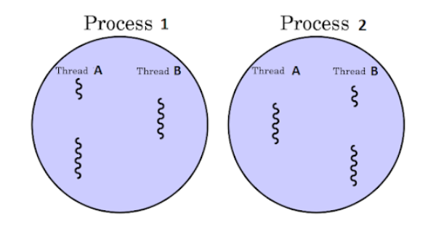

Q. What is the difference between Extend and Implement in Java?
S.No. | Extends | Implements
1. | By using “extends” keyword a class can inherit another class, or an interface can inherit other interfaces | By using “implements” keyword a class can implement an interface
2. | It is not compulsory that subclass that extends a superclass override all the methods in a superclass. | It is compulsory that class implementing an interface has to implement all the methods of that interface.
3. | Only one superclass can be extended by a class. | A class can implement any number of an interface at a time
4. | Any number of interfaces can be extended by interface. | An interface can never implement any other interface

Q. What is key and value?
Key:
The key acts as a unique identifier for the value. It's like the label on a drawer - you use it to find the content you want.
Value:
The value is the data itself, associated with a specific key. It's like the contents of the drawer.
Key-value pairs are commonly used in data structures like Maps (e.g., HashMap, TreeMap).

Q. What is Byte code?
Byte Code can be defined as an intermediate code generated by the compiler after the compilation of source code(JAVA Program). This intermediate code makes Java a platform-independent language.

Q. Why java support dynamic memory?
Java supports dynamic memory allocation for several reasons:
Flexibility and Efficiency:
- Unknown Memory Requirements:
In many scenarios, it's impossible to predict the exact amount of memory an application will need at compile time. Dynamic memory allocation allows programs to request memory as needed during runtime, making them more adaptable to varying workloads.
- Dynamic Data Structures:
Dynamic memory allocation is essential for creating data structures like linked lists, trees, and graphs, which can grow or shrink in size during program execution.
- Automatic Memory Management:
Garbage Collection: Java's automatic garbage collection eliminates the need for manual memory management. This relieves developers of the burden of explicitly deallocating memory, reducing the risk of memory leaks and other related errors.

Exception Hierarchy:
